Tail Recursion:
In recursion, last step should be recursive function call
This below tail recursion:
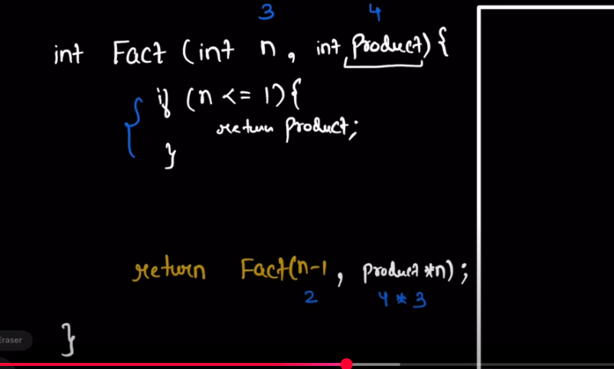

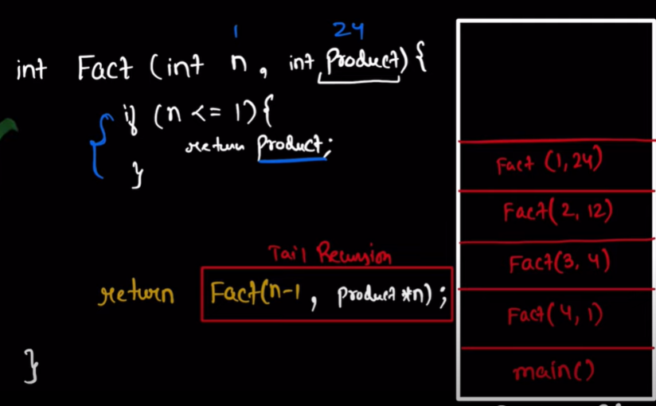
Compiler will automatically pop the frame stack if it is not used due to tail recursion

Tree Traversal:
Print Root, Left, right Pre-Order Traversal | Tail Recursion
Left, Right, Print Root -> Post Order Traversal | Tail Recursion
Left, print(root), Right, -> In-Order Traversal | Tail Recursion
